

Municipal Forestry Institute
Pre-Institute Assignment 2

Defining Your Professional Values

Description
Professional values are the core principles and beliefs that shape how we make decisions, interact with others, and show up in our work. They influence priorities, leadership approaches, ethical judgment, and how professionals navigate complex situations. The Defining Your Professional Values assignment is a self-directed exercise designed to help participants identify the personal values that most strongly influence their professional decisions and behaviors.
Professional values are woven throughout the MFI curriculum. Across the Institute sessions, group activities, and the MFI Learning Journal, participants will work independently and collaboratively with peers to surface, clarify, and apply their professional values as a foundation for intentional growth and continued professional development.

Learning Objectives
By the end of this assignment, participants will be able to:
- Recognize personal beliefs that guide professional behaviors, decisions, and priorities.
- Assess and analyze personal experiences to discover patterns that influence motivations, goals, and decision-making.
- Identify, describe, and share their personal and professional core values and beliefs.

Pre-Institute Assignment 2

Assignment
- Review the Pre-Institute Assignment 2 instructions, follow the steps and respond to the questions
- Perform a self-assessment using Brené Brown’s List of Values
- Fill out the values tables below
- Share values with peers at the virtual Pre-Institute Meeting on February 13, 2026.
- Bring this worksheet with you to MFI.

Additional Resources
- Article: https://pce.sandiego.edu/dare-to-lead-values/
- Podcast: https://brenebrown.com/podcast/living-into-our-values/
- Book: Dare to Lead, by Brenė Brown, pages 185-197
- Video: The Power of Vulnerability | Brené Brown | TED Talk

Identifying Personal and Professional Values
Personal values are the core principles and beliefs that guide our behavior, decisions, and interactions with others. They shape how we see the world, influence our goals, and determine what we consider important or worthwhile. Your core values serve as a compass for your lifestyle and work, determining direction, influencing decisions, and highlighting priorities.
Your values are shaped by your upbringing, life experiences, personality, and personal experiences, as well as culture and societal norms. Some values that affect how you make decisions may be obvious. But you may not realize that some deep-seated beliefs or core values are guiding your choices and actions.
Understanding your personal values is a pivotal step in emotional development because they act as a yardstick for evaluating whether your life is aligning with your aspirations and explain why you react to situations in certain ways. By cultivating awareness of these influential factors, you gain a valuable guide to navigate personal and work situations and make optimal choices.
Used in this way, your core values can be a barometer of your well-being, forecasting how you feel. When you are aware of your values and live by them, you may experience greater satisfaction and coherence in your life. Conversely, ignoring or compromising your values can lead to stress, dissatisfaction, or inner conflict.
In professional organizations, values are the bedrock of ethics and behaviors demonstrated in the workplace. They encompass the actions and essential skills that employers seek in their employees and - depending on your personal alignment with these set organizational values - may influence how you are perceived by colleagues, clients, or partners.
The awareness of your own professional core values empowers you to make informed decisions about how to shape and live your life and build a career that aligns with the aspects that bring you joy.

Defining Your Values
Defining your personal values can help you identify what is truly important to you. Follow these steps to recognize, identify and define your personal core values that will guide your life and career choices.

Step 1: Reflect
The first step to begin understanding your core values is to look back on your life and career. Think about impactful moments in your life and discover what is important to you through these questions. We can call it the 4Ws of values.
WHAT
Reflect on a time at work when you felt the happiest, most proud, and fulfilled. What was happening in those moments? What were you doing, and why was it meaningful? Who were you working with, and who shared in these feelings with you?

WHY
Think of a time when you felt most true to yourself? WHY did it feel that way? What are your personal deal-breakers or the things that drive you crazy.

WHO
Who are the people you admire who have shaped your deeply held beliefs, and what traits or principles make them stand out to you?

WHEN
Consider times WHEN you faced tough decisions or conflicts. What helped you navigate those situations? Who did you go to for support?

Step 2: Analyze
Once you've reflected on your life and gathered a collection of relevant past experiences, begin to analyze those experiences. To begin understanding how your personal values defined your experience, answer the following questions.
Using the significant experiences you listed above as a guide, consider the following questions:
Are there recurring values, qualities, ideas, or patterns that appear across multiple events?

What principle was driving your actions or feelings in those moments?

What guided most of your decisions?

What are the things you would not compromise under any circumstances?

Step 3. Identify
Identifying and clarifying the core principles and beliefs that guide your behavior, decisions, and priorities can give you deeper insight into what truly matters to you and how that shapes your personal and professional life. Identifying your values can enhance your self-awareness, align your actions with your values, and promote a feeling of purpose and fulfillment.
Review Brené Brown's List of Values listed below.
Begin by writing down, circling or highlighting the values that remind you of the experiences you reflected upon and that guide your direction, decisions and priorities. You might need to look up the definitions of some of the values. Consider other values you haven't encountered yet in your career but want to focus on going forward.
Choose at least 10 values from Brené Brown's List of Values that align with your core beliefs and experiences. The following steps will guide you in prioritizing your values, so don’t choose more than 15 values.
 | Value |  | Value
1 |  | 9
2 |  | 10
3 |  | 11
4 |  | 12
5 |  | 13
6 |  | 14
7 |  | 15
8

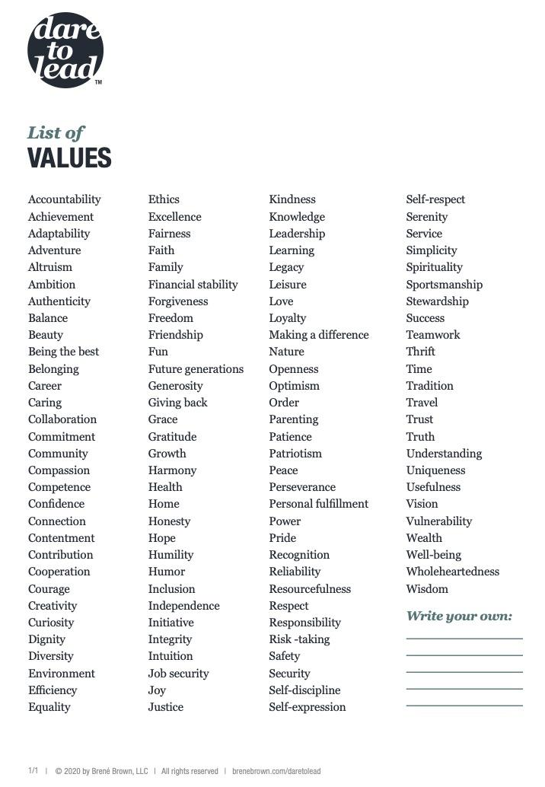

Step 4: Prioritize
Using the list of values that you identified, narrow down your list so that you end up with no more than 5 top values. To help you prioritize your values, answer the following questions. If it is useful, write them down below as you go.
It might help to visualize a situation in which you would have to choose between two values. For example, if you compare the values of service and stability, imagine that you must decide whether to sell your house and move to another place to do valuable aid work, or keep your house and volunteer to do charity work closer to home.
Which values best reflect who I am at my core?

What values guide me in times of difficulty?

Which values would I defend, even if it meant personal sacrifice?

What values make me feel fulfilled and at peace?

If I had to live by only a handful of values, which would they be?

The next step in prioritizing your values is to look for values that overlap or share a common theme. As you work through, you’ll find that some of these naturally combine. For example, integrity, honesty, and authenticity could form one group. Family, connection, and love could form another. As you group your values, choose the word that resonates most as a representative of each group. If you value philanthropy, community, and generosity, you might say that service to others is one of your top values.
Values Group | Value Group Name | Values Included

A

B

C

D

E

5. Rank Importance
Once you've organized your values into no more than 5 groups, attempt to rank these grouped values by importance. This process can help you acknowledge which of those values are most important and non-negotiable in your life or work.
Compare two values at a time and ask yourself, “If I could satisfy only value, which would I choose?” To visualize the significance of your values, place the most important value at the top of your list as you compare each one. Working through your list of values, comparing each value with the other values, until your list reflects the correct order of importance.
Your highest ranked values may stand out as essential to your identity and may feel non-negotiable - those values that you would not compromise, no matter the situation. This step may be the most difficult, because you'll need to reflect deeply about what is most important and meaningful to you. It's also the most important step because you’ll rely on it when making a critical decision that is forcing you to choose between solutions that satisfy different values.
For example, if you ranked humility high but rated recognition as not important to you then that might mean that receiving personal accolades is not important to you and you’d rather work behind the scenes. Your personal value of humility may cause you to step back and give someone else on your team, who really values recognition, an opportunity to be in the spotlight. This awareness can help you realize how you react in situations, what triggers you when others do something not in-line with your values, and how to reconcile the two.

Rank by  Importance | Value Name | Values Included

1

2

3

4

5

6. Define
After consolidating and prioritizing your values, you should define your top values for yourself. A personalized definition ensures the value resonates with your experiences, guiding principles, and aspirations. By crafting personalized definitions, your values become more actionable and serve as your compass for decision-making and goal setting.
Considering the preceding steps, create a definition that reflects how you embody your top 5 values. Regardless of the dictionary definition, what do the values mean to you? How do you know that you are living and working in alignment with your core beliefs? What do the values look like? Your value definitions should be concise, specific and brief. It should also be easy to remember and reflect your personal experience. You might want to include why the value is important to you.
Defining each value can help you communicate your values and understand how they function within your life and the day-to-day execution of your work. Through this process, you may discover how one value relates to another. You might find that defining and clarifying your values changes the ranking of their importance.
Rank by  Importance | Value Name | Value Definition

1

2

3

4

5

7. Values in Action
Associating specific behaviors or actions with each core value is essential to transforming abstract values into concrete, actionable practices, ensuring that your values are not just ideals but principles that guide your daily life. Values without action may remain aspirational and lack real influence over your decisions. By connecting values to behaviors, you can create a pathway for living in alignment with what matters most to you.
For example, if service to others is one of your top values, then associated actions or behaviors may be volunteering, being philanthropic, or giving back to your community in a specific way.
Associating specific behaviors or actions to your values can help you identify when you are truly living and working according to your values. It can also narrow your focus, helping you prioritize tasks and commitments that align with your core beliefs. These actions can be integrated into your daily routines and decision-making. They should be periodically reviewed and adjusted to ensure your behaviors stay aligned with your evolving values.

Rank by  Importance | Value Name | Associated Action

1

2

3

4

5

8. Personal Values Statement
The final step is creating a personal values statement that articulates the core principles that guide your life and explains how they shape your decisions and goals. This statement serves as a personal compass, helping you stay grounded and intentional in your actions. It will act as a guiding reminder of what is important to you.
Revisit and refine your personal and professional values periodically. Life experiences evolve, and so might your values. Reassess your values over time to ensure they align with your evolving life experiences.
Summarize your core values into a brief statement and write it below. Frame the statement as a reflection of who you are now, reinforcing that your values are an active part of your life. Your values statement should be concise, clear, and reflect your authentic voice.

My Personal Values Statement:

Don’t forget to bring this worksheet with you to MFI. It will be referenced during the sessions.

